Mixology From Home
Griffin Witt, Louie Finder, Ryan Grant, Timur Bashpanov
Point of contact email addresses: gwitt1@vt.edu, louiefinder@vt.edu, ryangrant@vt.edu, timur23@vt.edu
CS 4604, Dr. Nizamani
Spring 2026

Table of Contents

1. Brief Introduction 3
2. Normalized Relational Schema 3
3. Screenshots of Tables with Sample Data 4
4. Confirmation of DBMS-Interface Connection 4

1. Brief Introduction
The system addresses the challenge of managing cocktail recipes and ingredient inventories in a structured, scalable, and reliable manner. Existing approaches rely on fragmented online searches, manual recipe books, or disconnected mobile applications, which leads to issues such as time-consuming research, difficulty tracking available ingredients, inability to find drinks based on current inventory, and lack of personalized recommendations. These limitations motivate the need for a centralized, database-driven solution that accurately models real-world entities and their interactions.

2. Normalized Relational Schema
The submitted schema can be in a form of a snapshot of your actual tables in the database OR it could be submitted in way you submitted in the last phase. Both will be considered as correct.

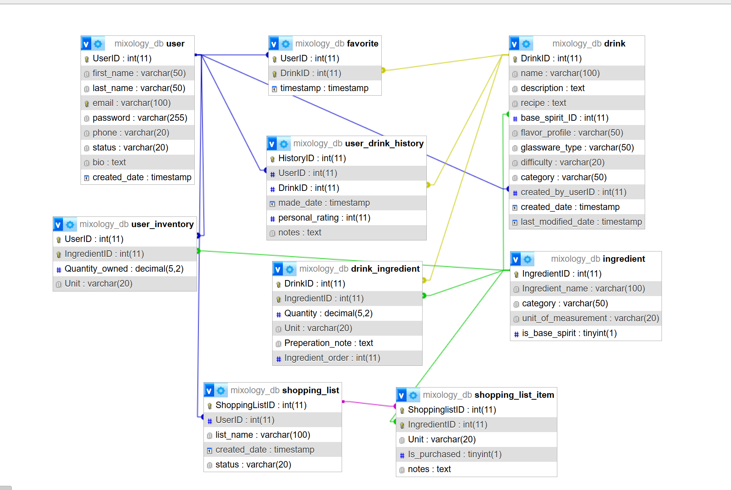

3. Screenshots of Tables with Sample Data
Provide screenshots showcasing tables populated with sample data. Screenshots should be provided for each table, showing the table name, attributes, and at least five sample records per table.

DrinkTable:
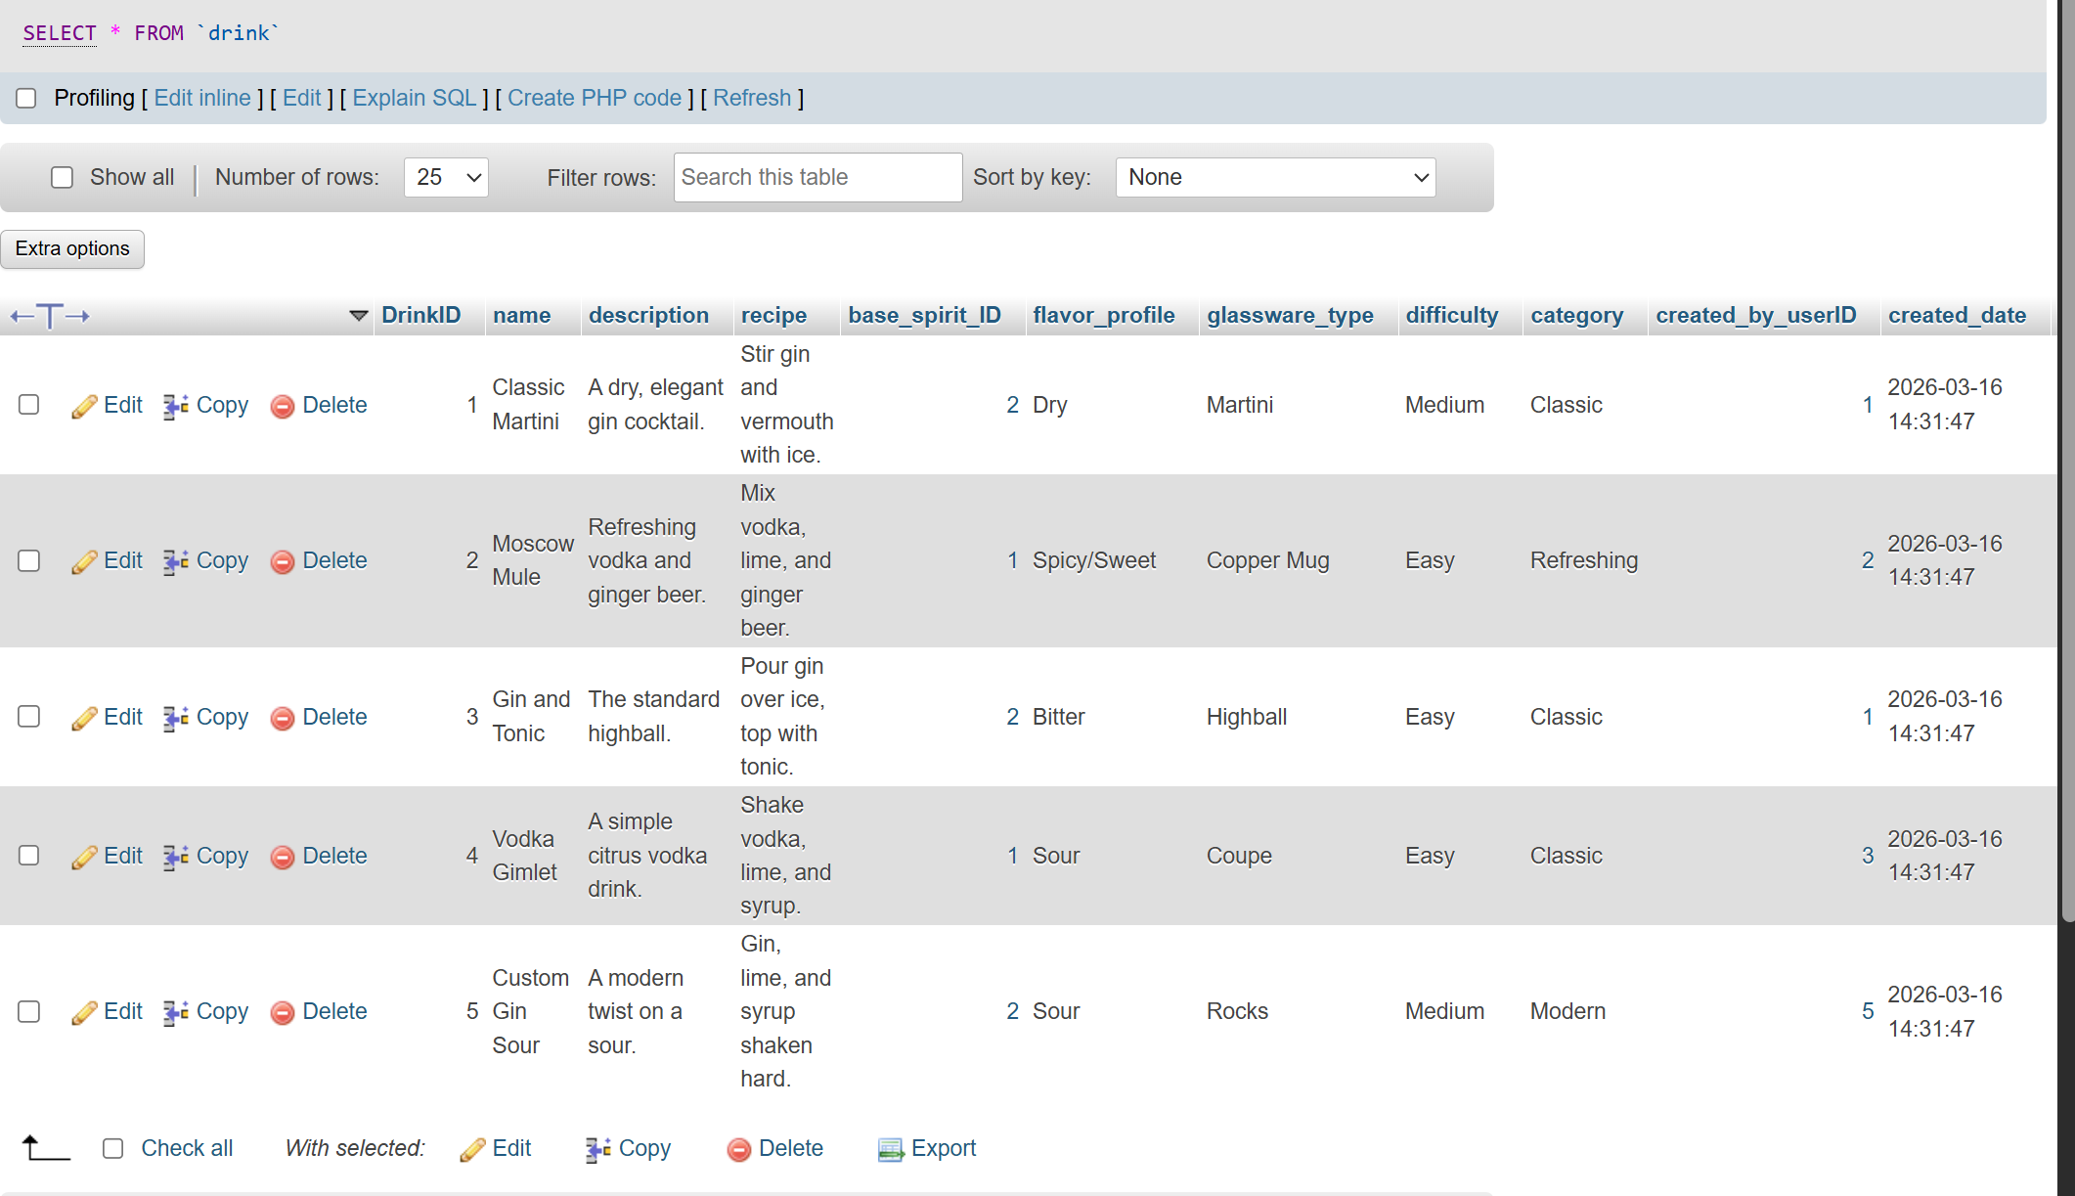
Drink_ingredient Table:
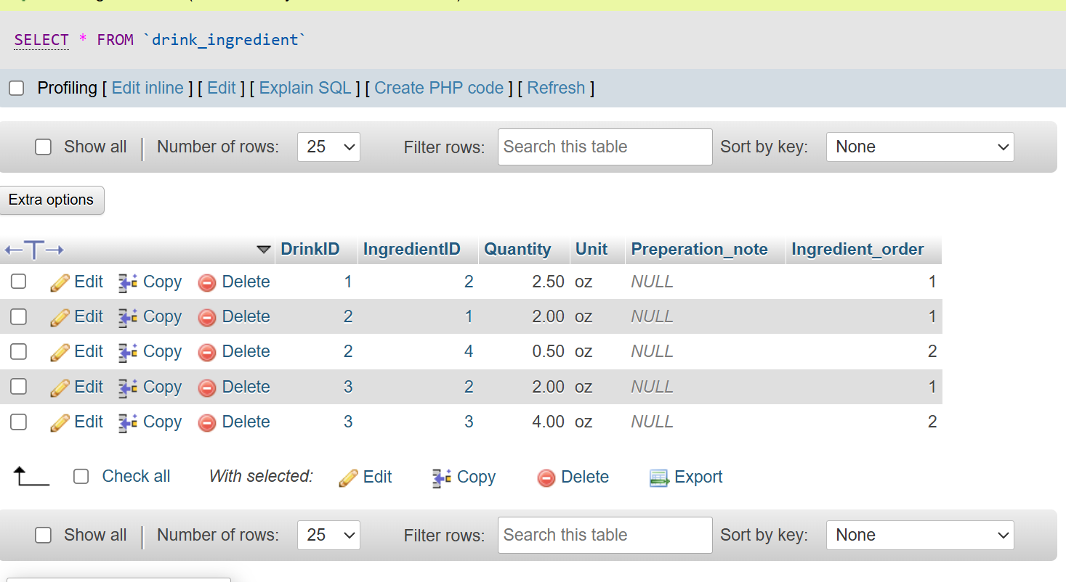
Favorite Table:
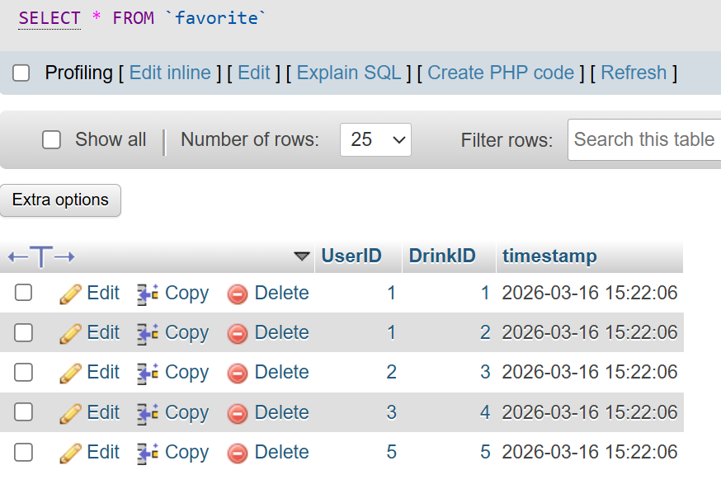
Ingredient Table:
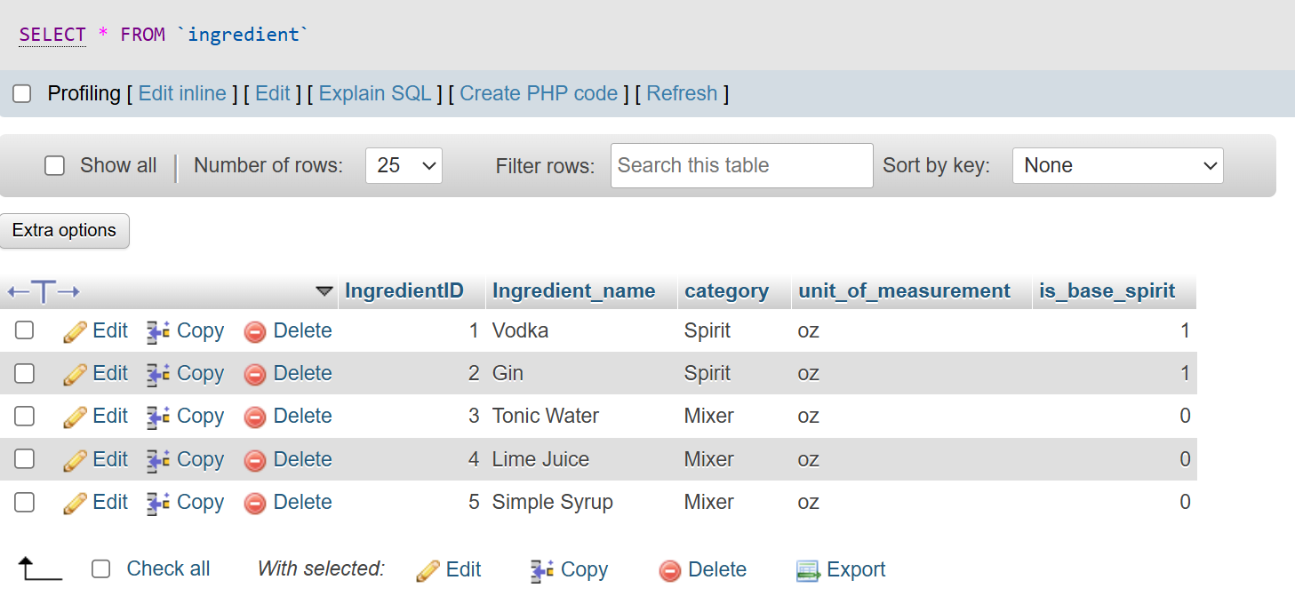
Shopping_list Table:
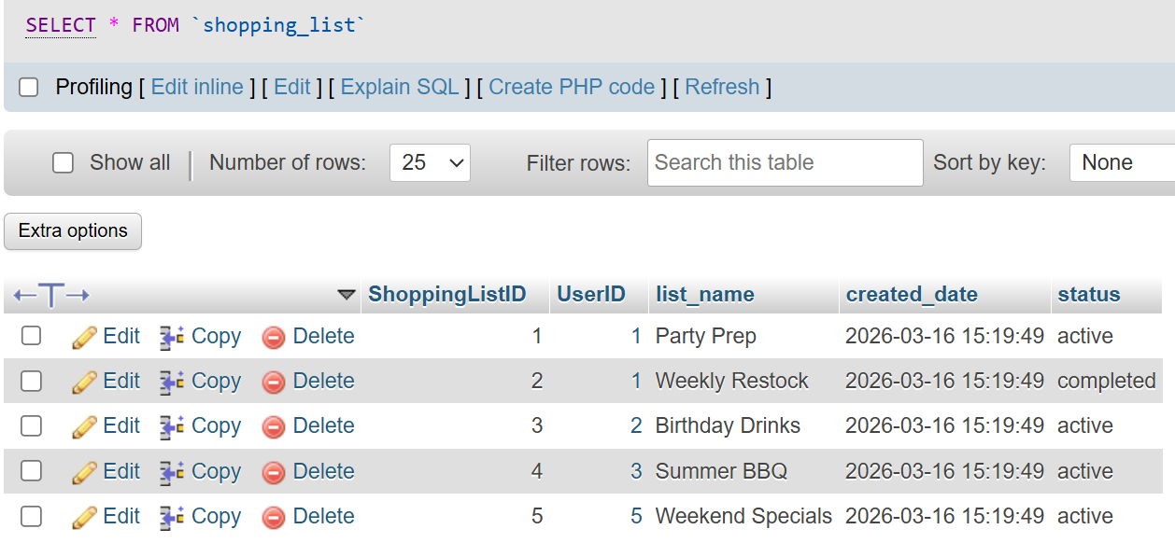

Shopping_list_item Table:
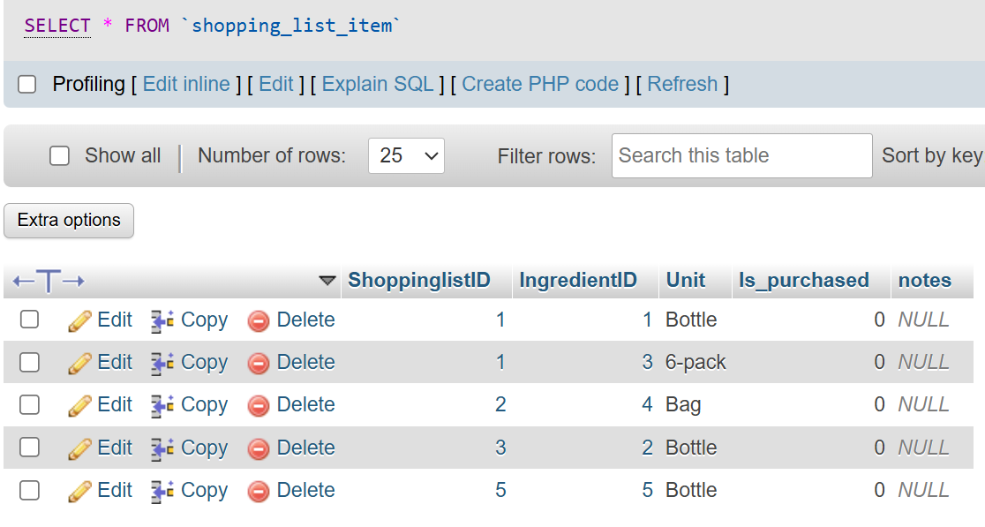

UserTable:
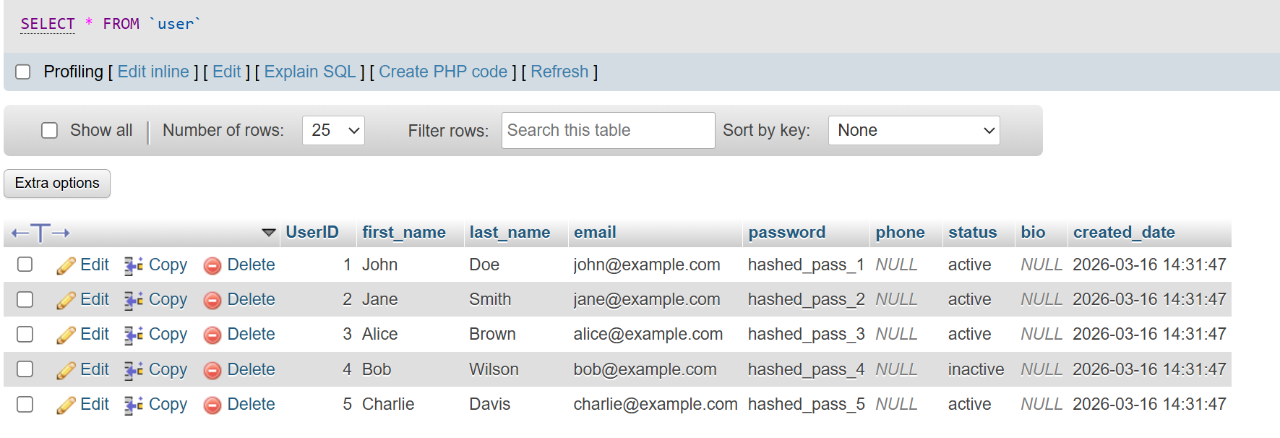

User_drink_history Table:
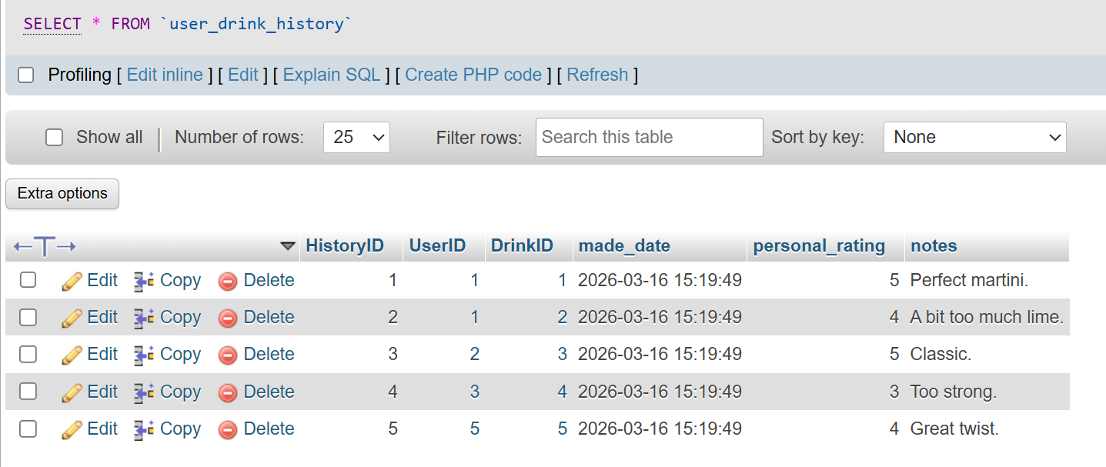

User_inventory Table:
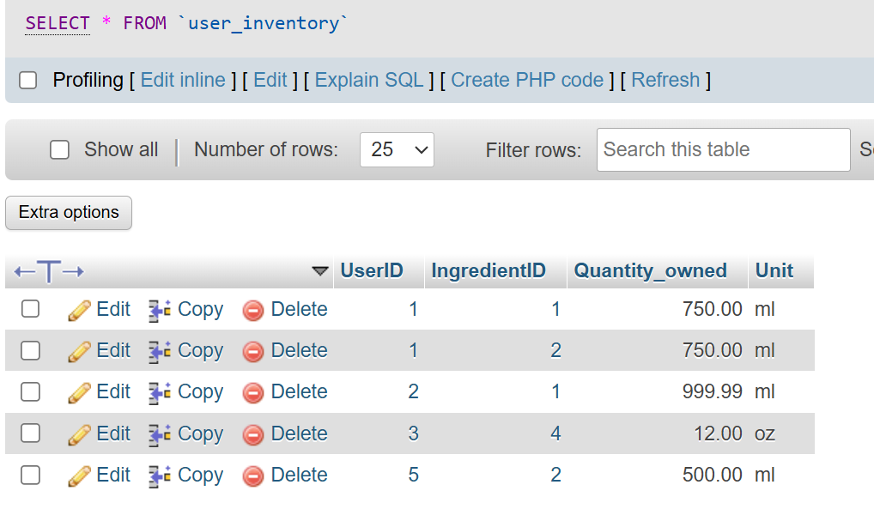

4. Confirmation of DBMS-Interface Connection
- DBMS Information:

The name of the DBMS used: Xampp with MySQL
The name of the interface language: php

- Submit a screenshot confirming successful connection establishment between the DBMS and the interface.

We used a Web Interface, a web page running on localhost displays a success message “Connected to Database!”, indicating that the application has successfully connected to the database.

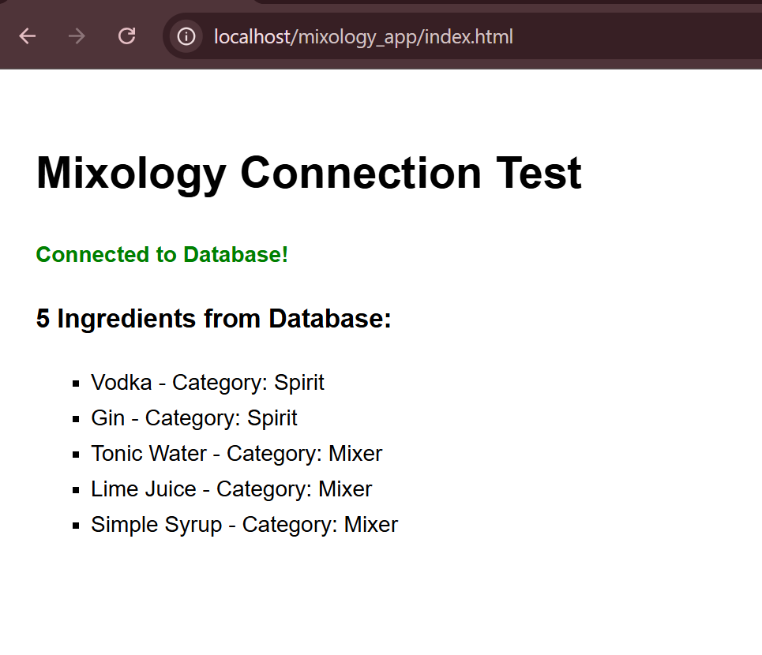

Additional Notes:
- Maintain consistency with defined data types for attributes.
- Ensure accurate establishment of primary and foreign keys within the tables.
- Use of frontend design tools, frameworks is allowed.
- Use of generative AI such as Copilot, ChatAI to design frontend is allowed.

